Closing the Gap (MEASURE) Report
Stefani Spradling, Kennedi L. Slayton, Lisa Stimson, & Breanna Irving
School of Psychology & Counseling, Regent University
COUN 519: Program Development & Evaluation for School Counselors
Professor Lisa Mandia
November 30, 2024

Closing the Gap Report (MEASURE)
Name and Address of School: Francis Scott Key Middle School, 10 Schindler Drive, Silver Spring, MD 20903
Name of Counselor(s) Leading the Initiative:
Stefani Spradling, Kennedi L. Slayton, Lisa Stimson, and Breanna Irving
Principal: Jane Doe
Enrollment: 965
School Demographics:
- Minority Enrollment: 97.5%
- African American: 40.1%
- Caucasian/non-Hispanic: 2.5%
- Hispanic: 46.1%
- Asian/Pacific Islander: 9.5 %
- Native American or Alaskan Native: 0.2%
- Multiple Races: 1.5 %
- Free-Reduced Lunch: 72.7%
- English as a Second Language: 35%
- Exceptional Student Education/Special Education: 11.2%\
- Male: 52%
- Female: 48%
Student Enrollment (Numbers)
Demographic Breakdown
Black or African American | 387
White/non-Hispanic | 24
Hispanic | 445
Asian/Pacific Islander | 92
Native American or Alaskan Native | 3
Multiple Races | 14
Free or Reduced Lunches | 772
ESOL | 155
EXCEPT/SPED | 110
Male | 499
Female | 466

Student Disciplinary Offense Disaggregated by Ethnicity and SES Status
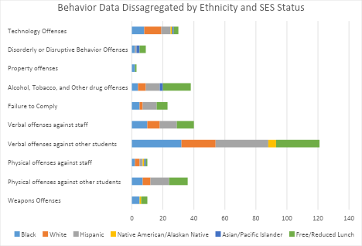
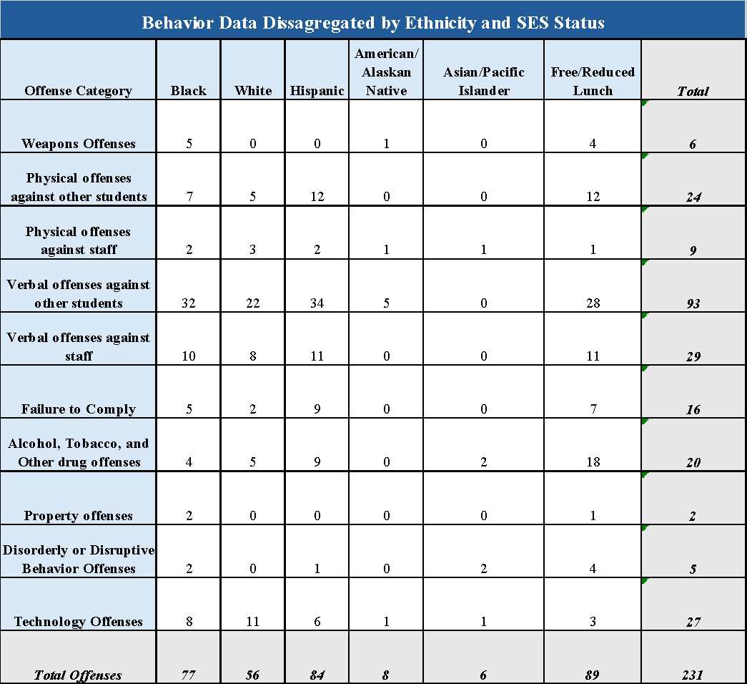

Step One: Mission
School Mission
The Francis Scott Key Middle School’s mission is to partner with culturally diverse parents, students, and community members to ensure student excellence and success by providing a safe and inclusive environment that fosters student growth and development.

Step Two: Elements
Current Critical Data Element(s)
In collaboration with teachers and administration, the school counselor(s) have identified these critical data elements to try to impact:
- In the Fall 2023-2024 semester, 93 verbal offenses towards students by peers have been reported. Of those incidents, the highest numbers have been among Hispanic, White, and Black students. 38% of those who committed verbal assaults against peers also identified as receiving free or reduced lunch.

Step Three: Analyze
Baseline Data | Goal
1. A total of 93 verbal offenses towards students were reported, with the highest incidents occurring between Hispanic, White, and Black students in the Fall semester. | 1. By the end of the 2023-2024 school year (Spring Semester), the number of students who have committed verbal offenses toward another student will decrease by at least 5%.

Step Four: Stakeholders-Unite
Stakeholders | Strategies
Beginning date: January 2024
Ending date: June 2024
School Counselors | - Conducted a survey or analyzed referral data to identify the baseline number of verbal offenses and identify patterns (e.g., grade level, location, or time of day).  - Input was gathered from teachers, staff, and students about triggers and hotspots for verbal conflicts.  - Grade-specific SEL lessons focused on empathy, conflict resolution, and effective communication.  - Conducted small groups for individuals identified with higher needs.  - Meeting with frequent offenders and assigned trained peer mentors who model respectful communication.  - Provided stakeholders with strategies to de-escalate verbal conflicts and reinforce positive classroom interactions.  - Creating a recognition program for students who demonstrate improved peer communication.  - Used regular check-ins with at-risk students to assess progress and provide ongoing support.  - The recorded amount of verbal offenses was found to identify patterns and triggers that can be addressed collaboratively with teachers and administrators.  - Collected and compared verbal offense data monthly to evaluate trends and adjust interventions if necessary.  - Conducted a follow-up survey and analyzed referral data to measure progress toward the goal.  - Shared results with stakeholders, highlighting successful strategies and recommendations for sustained improvement.
Teachers | - Established and consistently enforced classroom rules regarding respectful communication.  - Incorporated activities and discussions on empathy, active listening, and managing disagreements.  - Dedicated time for check-ins and collaborative discussions to build community and improve peer relationships.  - Identified and referred students who frequently engage in verbal offenses and referred them for small group counseling or other interventions.  - Participated in a school-wide initiative called the “Caught Being Kind” program, where students are rewarded for positive behavior.  - Shared concerns and progress with families to ensure they reinforce respectful communication at home.
Administrators | - Developed and communicated a zero-tolerance policy for verbal harassment and offensive language.  - Incorporated social-emotional learning (SEL)frameworks into staff development days.  - Created opportunities for students involved in verbal offenses to engage in therapeutic conversations that repair harm.  - Created initiatives like "Students of Character" awards or shout-outs for students who exemplify respect.
Parents | - Participated in a psychoeducational forum to aid children in learning how to handle disagreements calmly and respectfully in daily interactions at home and in the community.  - Attended the “Diversity against Adversity” meeting during back-to-school events.  - Guided the child to take responsibility, apologize, and make amends when necessary.
Students | - Demonstrated kindness, active listening, and respectful dialogue in interactions with peers.  - Actively avoided gossiping or using negative language and encouraged others to do the same.  - Actively engaging in respectful interactions with others, even if they may differ from oneself.  - Reported behaviors of students who may not have been seen or heard by a staff member or administrator.  - Participated in a peer-mentoring program to help students be better classmates.
Community Partners | - Connected with local counselors, conflict resolution experts, or anti-bullying organizations can lead workshops on communication skills, empathy, and conflict resolution for students, staff, and parents.  - Worked with multicultural organizations to help families from diverse backgrounds understand and contribute to the school’s behavior expectations.  - Connected students with mentors who can guide them in developing respectful communication skills and navigating challenges.  - Partnered with schools to offer sessions for parents on managing conflicts at home and reinforcing respectful behavior.

Step Five: Reanalyze, Reflect, and Revise
Reanalyze Baseline Data
Student Verbal Offense Data
 | # of Verbal Offenses Against Peers |  | Hispanic | White/non-Hispanic | Black or African American | Other | Free and Reduced Lunches
1st Quarter | 33 |  | 10 | 9 | 12 | 2 | 12
2nd Quarter | 60 |  | 22 | 13 | 22 | 3 | 16
Primary Data Totals | 93 |  | 32 | 22 | 34 | 5 | 28
 |  | Program Implementations After Winter Break
3rd Quarter | 54 |  | 19 | 15 | 19 | 1 | 15
4th Quarter | 30 |  | 11 | 10 | 8 | 1 | 9
Outcome Data Totals | 84 |  | 30 | 25 | 27 | 1 | 24
- Baseline data: There were 93 total verbal offenses reported during the Fall 2023-2024 school semester, with Hispanic, White, and Black students having the most incidents recorded.
- Final data: After the implantation of the SEL and other interventions, verbal offenses decreased by 12%, decreasing from 93 to 84.

Effective Strategies
- Counselors provided several grade-specific SEL lessons focused on empathy, conflict resolution, and effective communication.
- Small groups were facilitated to engage with identified students with elevated behaviors.
- Implementing teacher training to help with strategies to de-escalate verbal conflicts and reinforce positive classroom interactions has given many teachers and support staff confidence.
- The recognition program was well received by students who demonstrated improved peer communication, which increased peer relations in classrooms and the halls.
- Implementing the school-wide initiative called the “Caught Being Kind” program, students were rewarded for positive behavior, encouraging their peers to adjust some disruptive or unkind behaviors.
- Recognizing the "Students of Character" and facilitating monthly awards and morning shout-outs for students who exemplified respectful and kind character to peers and staff.
- Regular check-ins with at-risk students to help assess their progress and provide ongoing support.
- The collected evaluations found trends that helped adjust interventions that targeted a specific student population struggling with internal and external issues or barriers.
Areas of Improvement
- More time for training in strategies to de-escalate verbal conflicts and reinforce positive classroom interactions is needed for educators and support staff.
- A more structured implementation plan regarding training time is needed to match frequent offenders to trained peer mentors who model respectful communication.
- More time or interactive online training is needed for staff to use social-emotional learning (SEL) frameworks during development days or to access them during planning.
- Improving accessibility for families unable to attend events or workshops due to transportation or irregular work schedules.
Systemic Changes Made
- A zero-tolerance policy for verbal harassment and offensive language is challenging to execute fully due to the discovery of socioeconomic barriers for some students.
- Linking families suffering from financial instability to more resources will help reduce household stressors.
- Improvement of verbally aggressive behaviors may require more outside culturally literate organizations to speak to introduce inclusivity and discuss racial issues that affect harmony among communities.

Step Six: Educate
MEASURE
School Counseling Program Accountability Report Card
School: Francis Scott Key Middle School
Enrollment: 965
Principal: Jane Doe
Counselor: Lisa Stimson

Principal’s Comments | Results
“The current programs implemented to reduce overall verbal offenses within the school community are thriving. The counseling team has effectively administered interventions demonstrating improvement in classroom and extracurricular environments. “  - Jane Doe, Principal | Baseline Data:  93 verbal offenses were identified to have occurred against student peers in the first semester.  Final Data:  After implementing SEL and other program interventions, verbal offenses decreased to 84 in the second semester.  Percent Change: 12%
School Improvement Issues
“Closing the Gap” Goal: By the end of the 2023-2024 school year (Spring Semester), the number of students who have committed verbal offenses towards another student will be decreased by at least 5%; the goal reached was 12%, with 93 incidents decreasing to 84.
The Francis Key Scott school’s mission is to partner with culturally diverse parents, students, and community members to ensure student excellence and success by providing a safe, inclusive environment for students to thrive. By cooperating with and cultivating programs with teachers’ administrators, parents, students, and community stakeholders, we can provide students with the means necessary to succeed and become upstanding members of their community.

Critical Data Element(s)
In a recent data pull, the school counseling team identified an increase in verbal offenses (93) among students in the Fall semester, especially those identifying as Hispanic, White, and Black.
Stakeholders
School Counselors: Facilitating data collection to identify trends and focus resources to address issues reported by other stakeholders. By collaborating with several departments to ensure the efficiency of programs initiated, holding involved stakeholders accountable, identifying students with higher needs, and tracking the progress of the Closing the Gap program to decrease tensions within the school community. SEL workshops were employed in several classrooms and small groups with identified repeat offenders or individuals with high behavioral needs.
Teachers: Identifying students with specific needs, facilitating dialogue, and de-escalation techniques within the classroom before seeking administration or disciplinary action. Provided morning check-in to assess social climates within the school and communicated more frequently with parents, which helped address and identify external and internal stressors. Participation in the “Caught Being Kind” program positively impacted the classroom as the focus highlighted positive conduct rather than negative actions.
Administrators: Provided segmented time within professional development days to aid the counseling department in equipping other stakeholders with classroom management tools and de-escalation interventions. Coordination of assemblies for highlighting
Parents: Participated in workshops and attended back-to-school assemblies to aid in dialogue with their students about conflict resolution and provided accountability for actions that stakeholders identified.
Students: Participation in school-wide initiatives and activities, as well as mentorship of identified peers, encouraged the creation of a safer and kinder learning environment.
Community Members: Organization, community mentors, participation from other schools within the district, and connecting with local mental health professionals contributed to encouraging families in need to become more engaged with the school's current issues. This created buy-in from the community to encourage students' growth as future community members.
Human Faces Behind the Data Anecdotal Outcomes
Students have acknowledged that verbal offenses are equally damaging to peers as physical aggression, and it is not a constructive way to express displeasure or resolve conflicts. Students identified as repeat offenders of verbal incidents were addressed more therapeutically to get to the root of their anger or pain. External stressors were identified as some of the origins of these negative behaviors, which facilitated the counseling staff's initiating the collection of more significant resources for students and their families. Several parents and community members have reached out to the school to express their gratitude for addressing these behaviors and volunteered their time to extend the current initiatives within the school environment.

Closing the Gap Narrative
The school counselors understand that merely addressing disruptive behaviors does not fix the issues on campus. However, it must be recognized that these behaviors stem from more complex socio-environmental problems. Students who exhibit aggressive or racially charged verbal attacks do so frequently due to misinformation and misinterpretations of the language they encounter in their surroundings. Research indicates that exposure to social media and socioeconomic challenges can foster negative perceptions and stereotypes about individuals perceived as different, which students may replicate with peers (Laninga‐Wijnen et al., 2021). By providing tools to educators and other stakeholders, counselors help broaden their understanding of student behavior, which is usually influenced by external factors rather than mere attention-seeking. The facilitation of psychoeducational interventions and small groups can aid in addressing the immediate fostering of empathy, handling anger, disproving stereotyping and labeling, and engaging in proactive dialogue with peers and staff members. However, parental and community support is also needed.
There are a significant number of students at Francis Scott Key Middle who face socioeconomic or other hardships that create additional stressors within their lives that hinder their academic performance and functioning in the classroom. These stressors may cause heightened emotional responses and behavioral issues, requiring a proactive approach to mitigate the impact in classrooms and on campuses. Research has shown that programs have effectively reduced negative behaviors by implementing psychoeducational resources for stress management and fostering a positive school climate (Holmes et al., 2014; Cook et al., 2018). Counselors and stakeholders can also effectively establish a supportive environment through positive reinforcement and reward programs (or develop influential token economies for excessive behavioral incidents); it encourages students to engage in constructive behaviors, enhancing their academic and social experiences (Türkoğlu, 2019).
Peer dynamics are another critical factor in shaping student behavior, particularly aggression and social acceptance. When aggressive behaviors are normalized within peer groups, this often leads to reinforcement of behaviors that become admired, especially by those who seek attention. Consequently, promoting positive peer norms through mentorship programs and collaborative activities can significantly alter the classroom climate, fostering an environment where prosocial behaviors are valued over aggressive actions (Guimond et al., 2018; Laninga‐Wijnen et al., 2019). When teachers, counselors, parents, and the broader community are involved, it creates a cohesive support system that addresses these issues holistically, thereby contributing to a safer and more inclusive school environment (Ni'mah, 2023).
Addressing student behaviors requires a multifaceted, holistic approach considering social media influences, socioeconomic factors, and peer dynamics. Schools can effectively close achievement gaps by equipping students with the tools to manage stress and promoting positive behaviors through structured support systems. The comprehensive school counseling program has been developed to address these needs with the identified population so schools may continue working to make our campuses a safer and more cohesive environment to thrive. The participation of stakeholders, including the administration, faculty, parents, and community members, has made this opportunity to facilitate a successful program achievable.

References:

Cook, C., Fiat, A., Larson, M., Daikos, C., Slemrod, T., Holland, E., … & Renshaw, T. (2018). Positive Greetings at the Door: Evaluating a Low-Cost, High-Yield Proactive Classroom Management Strategy. Journal of Positive Behavior Interventions, 20(3), 149-159. https://doi.org/10.1177/1098300717753831
Francis Scott Key middle stats. (n.d.). Usnews.com/education. Retrieved November 24, 2024, from https://www.usnews.com/education/k12/maryland/francis-scott-key-middle-262879#data
Guimond, F., Brendgen, M., Correia, S., Turgeon, L., & Vitaro, F. (2018). The moderating role of peer norms in the associations of social withdrawal and aggression with peer victimization. Developmental Psychology, 54(8), 1519–1527. https://doi.org/10.1037/dev0000539
Holmes, B., Gibson, J., & Morrison-Danner, D. (2014). Reducing aggressive male behavior in elementary school: promising practices. Contemporary Issues in Education Research (Cier), 7(4), 253–258. https://doi.org/10.19030/cier.v7i4.8838
Laninga‐Wijnen, L., Berg, Y., Mainhard, T., & Cillessen, A. (2021). The role of aggressive peer norms in elementary school children’s perceptions of classroom peer climate and school adjustment. Journal of Youth and Adolescence, 50(8), 1582-1600. https://doi.org/10.1007/s10964-021-01432-0
Laninga‐Wijnen, L., Steglich, C., Harakeh, Z., Vollebergh, W., Veenstra, R., & Dijkstra, J. (2019). The role of prosocial and aggressive popularity norm combinations in prosocial and aggressive friendship processes. Journal of Youth and Adolescence, 49(3), 645-663. https://doi.org/10.1007/s10964-019-01088-x
Ni'mah, N. (2023). The effect of interactive media-based role-playing on elementary school students' social attitudes and learning outcomes. Pedagogik Journal of Islamic Elementary School, pp. 1–10. https://doi.org/10.24256/pijies.v6i1.3784
Türkoğlu, B. (2019). Preschool teachers’ perspectives on aggressive behaviors in children: a qualitative study. Journal of Education and Training Studies, 7(2), 169. https://doi.org/10.11114/jets.v7i2.3889
Vitaro, F., Brendgen, M., Girard, A., Boivin, M., Dionne, G., & Tremblay, R. (2015). The expression of genetic risk for aggressive and non-aggressive antisocial behavior is moderated by peer group norms. Journal of Youth and Adolescence, 44(7), 1379-1395. https://doi.org/10.1007/s10964-015-0296-y

